PREDICTION ESTIMATED COST HEALTH INSURANCE

Kübra Elif TOZKOPARAN
Faculty of Engineering, Department of Software Engineering, Fırat University
Elazığ. Turkey
15290028@firat.edu.tr

– Abstract –
A health insurance is a type of insurance that is voluntary in order to provide economic assurance for health problems that may result in illness or accident. Anyone with the necessary conditions from 18 to 65 can benefit from the health insurance service. Health care is important in many health care applications as well as in determining insurance costs. Some proposed "cost coverage" policies can lead to welfare losses for insurers, and even increase the number of uninsured people. Health insurance makes a refund as a function of expenditure or use. As insurance reduces the marginal cost of medical care on the job by almost zero, the usual opinion, consumers or doctors acting as mediators, demand maintenance until the marginal product of supplementary care is almost zero. [1] Real medical care expenditures per capita are increasing by about 4 percent annually, with the exception of the 1960s, when the growth rate is even faster, and the share of health care expenditures in these growth rates is steadily increasing. In this study we tried to estimate the personal medical expense with Linear Regression in the light of the data obtained from the health insurance company. Using 10k cross validation, the estimated value is calculated with a difference of 19%.
Keywords; Health insurance, cost, estimation, data, individual medical expenses

I. INTRODUCTION
Today, the number of and quality of services provided by private health organizations is worth noting that the trend to private health institutions with the same percentage increase, but also that although the existing costs during the drug or the treatment of private health care institutions is normal revenue base is an unavoidable fact. Insurance companies also plan to avoid these difficulties if they are faced with any health condition, regardless of the current financial situation. Insurance companies, in order to profit from the amount paid to the insured person must receive higher premiums. For this reason, insurance companies spend a lot of time, effort and money to create models that accurately predict health care costs. Data mining tools and techniques can be used to detect large insurance forecast data. It does not work to find the cost probabilities of the insurance cost estimates of the persons given various parameters in the direction of the predetermined dataWith this report we have created data analysis to explore factors affecting medical costs and ultimately aims to create a predictive model. Unlike most other computer software, data mining systems do not show that an event has mathematical validity.
Based on various parameters, it calculates the likelihood of each insurance estimate by analyzing the pre-paid health insurance cost. Data mining techniques are used to detect large amounts of data. Data mining, which is part of a larger concept of information discovery, includes statistical, mathematical, artificial intelligence and machine learning techniques for obtaining and describing useful information and subsequent information from large databases. [2] There are several different data mining functions that use specific algorithms. [3] Some of these functions and algorithms are presented in Table 1 together with the application examples.

Table 1. Data mining functions and algorithms
Data mining function | Algorithm | Application example
Associations | Statistics,set theory | Market basket analysis
Classification | Decision trees, neural networks | Risk assessment
Clustering | Neural networks, discriminant analysis | Market segmentation
Modeling | Linear and nonlinear regression | Sales forecasting
Sequential patterns | Statistics, set theory | Market basket analysis over time

In this article, cost estimation and possible data in the health insurance sector and techniques for detecting them have been studied. There are many studies in the literature about estimation of health cost. In the study conducted in 2006, the criterion was obtained with a difference of 35% for the effectiveness of health information technology in improving quality and productivity. [3] In the study conducted in 2007, the differences between male and female occupational status groups between 30-70 for the West German population were examined. Methods used were health insurance data collected between January 1987 and December 1996. The main variables were age, age of death and occupational status. All insured men employed (N = 80,172) and women (N = 32,166) who were employed or employed before retirement were classified according to their latest occupational status (semi-skilled / unskilled, skilled, unskilled, intermediate level profession / profession). The forecast value is 34% according to the highest occupational group, the relative risks are calculated by logistic regression. [4] It is a work done in 2010 to make it useful for consumers who have to pay for fraud in the form of high insurance premiums in the study and it is estimated value by 32.7% difference. Many machine learning algorithms are used in these models. Regression analysis finds use in many branches of social sciences. [5] In the determination of behavioral movements in science branches such as marketing, sociology and psychology,determination of the factors affecting economic variables of the time series type in the economy and (forecasting) projections for the future. [4]
Using linear regression, age, gender, body mass index, number of children in possession, smoking status, region information and insurance costs information were used to estimate insurance premiums. Table 2 gives definitions and definitions.

Table 2 gives definitions and definitions.
Age | An integer indicating the age of the primary beneficiary (18-64 age range as indicated by the government)
Sex | The categorical variable (male-female) indicating the sex of the primary beneficiary .
Bmi | The body mass index is found by dividing the weight of the primary beneficiary by the height in meters (kg / m ^ 2). An ideal BMI should be between 18.5 and 24.9.
Children | An integer that indicates the number of children that the primary beneficiary covered by the insurance plan has.
Smoker | The categorical variable (yes-no) that indicates whether the primary beneficiary is smoking.
Region | The primary beneficiary's US residence is divided into four geographical regions: northeast, southeast, southwest or northwest
Charges | Dependent variable - measures the medical costs of each person taken on the insurance plan for the year.

In this study, the analysis method using the values of charges was applied to determine insurance estimates. It has 7 classes and 1338 doses. We will try to establish the most accurate model possible for this core. The most interesting here are estimates of insurance premiums at variable rates. Estimated value was calculated with a difference of 19% in the designed model.

II. LİNEAR REGRESSİON ANALYSIS

The change on the dependent variable, how much it arises due to the independent variables,

It is tried to determine the value of the dependent variable according to the values of the independent variables.

The regression analysis, in which the relation of an independent variable to a dependent variable is examined, is called linear regression analysis.[7]

How the independent variables affect the dependent variable is called the regression analysis by describing the other (or others) as the independent variable (s) and the related mathematical function (function) between them, taking the variable as the variable (the procedure dependent variable). [6]
How the independent variables affect the dependent variable,
Correlation Coefficient:
R: The grade of the relationship between dependent and independent variables. It is the linear correlation coefficient between two variables.[5]

Model accountability:
R^2 ( R Square) : It is called the determination coefficient. The variance of the independent variable is the percentage of change over the dependent variable. [4]

III. DATA ACQUISTIONS
In this study, an insurance company's database was used in the USA. The database contains certain physical characteristics and habits of the insured person. [8] The system is 'trained' to determine estimated values by actual value. Our data are based on age, gender, body mass index, number of children, smoking status and region, but for our tests, an obesity parameter was added to the dataset for those with a body mass index greater than 30. R is the regression data analysis. The sample dataset is given in Table 3. This data set has no lost value.

Table 3. Insurance dataset

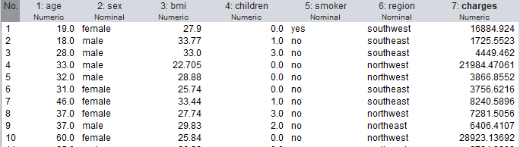
Let's start with the distribution of fees for examining the relation of fees according to their categorical characteristics.

Table 4. Price distribution chart
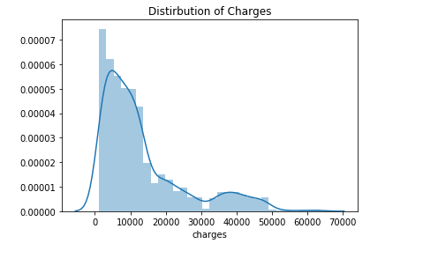
The graph shows that you are bowing to the right. We can say visually that it may be discriminatory (the maximum fee is $ 63,770). Let's review it again between groups this time.

Table 5. Data exploration descriptive analysis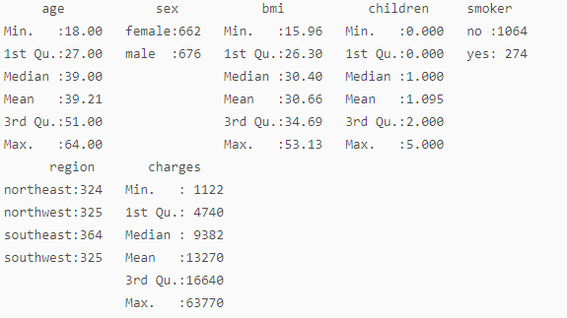

Gender and territory of respondents are equally distributed and ages range from 18 to 64 years. Non-smokers are 4 times more than smokers. [5] The average medical cost is $ 13,270. As mentioned earlier, the dataset is a striking piece, so we can continue without having to affect any data.

Table 6. Interregional descriptive pricing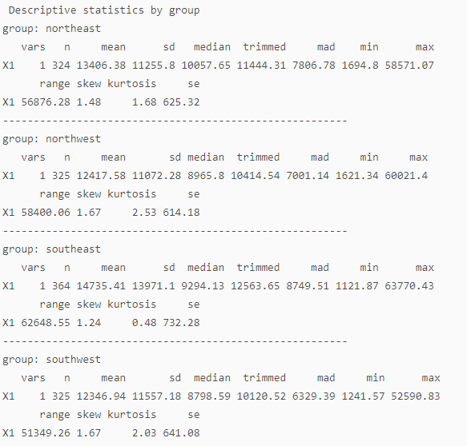

As we can observe, the region does not have much effect with the amount of medical cost. We can see convergence by looking at Median valuesThus, when modeling, region = NorthWest model should be removed.

Looking Visualization;

Table 7. Inter-region pricing schemes boxplot chart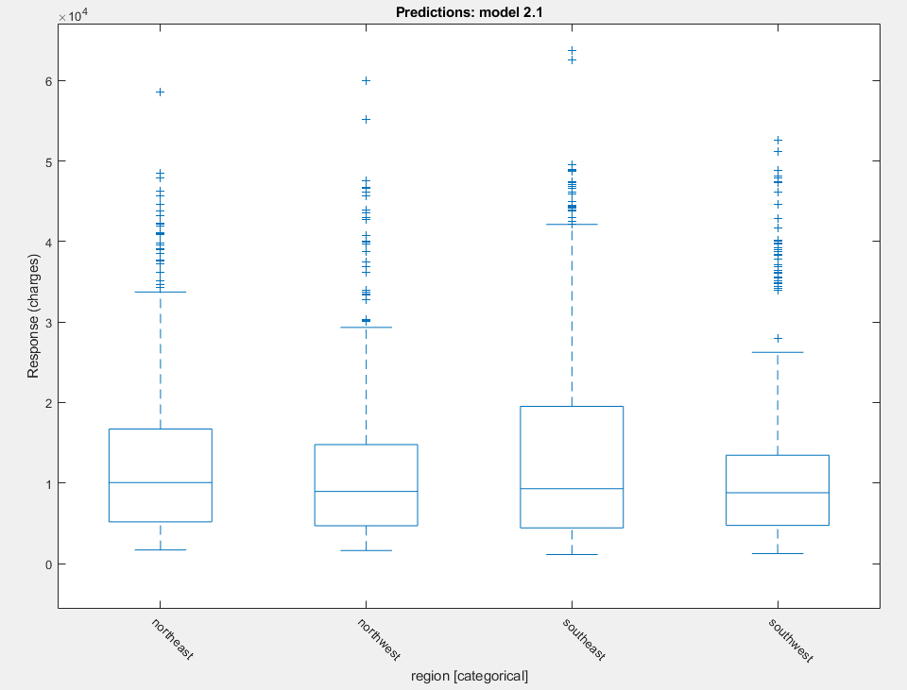

Table 8. Descriptive pricing according to whether they smoke or not

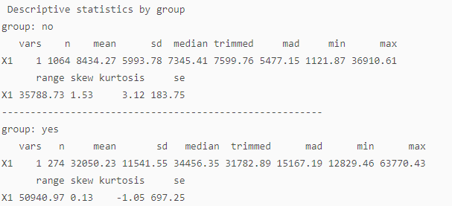

On the other hand, the same can not be said for the smoking situationIt is clear that smokers spend a lot more money on medical expenses almost 4 times more than non-smokers. There is a $ 23,615 difference between smokers and non-smokers. Smoking is really expensive. [11]

Table 9. Charge-wise boxplot charts based on smoking.

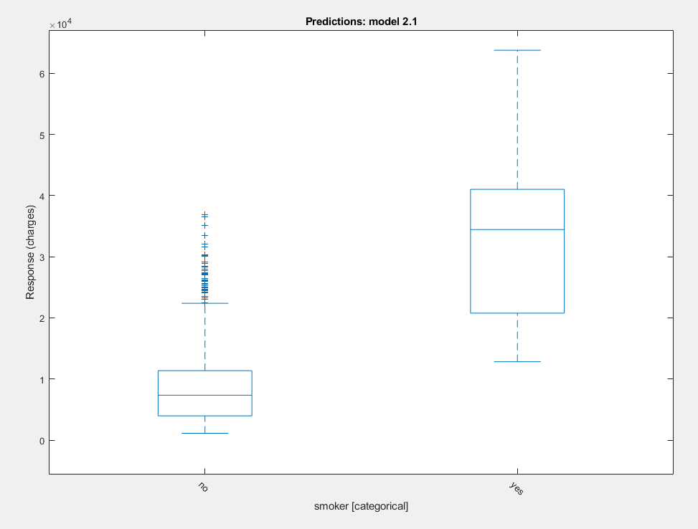

Table 10. Descriptive pricing by gender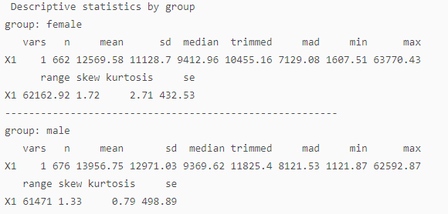
Medical expenditures also seem to be unaffected by sex. Median values are close to each other. [14] Thus, when modeling, gender should be excluded from modeling.
Table 11. Rates by sex, boxplot chart
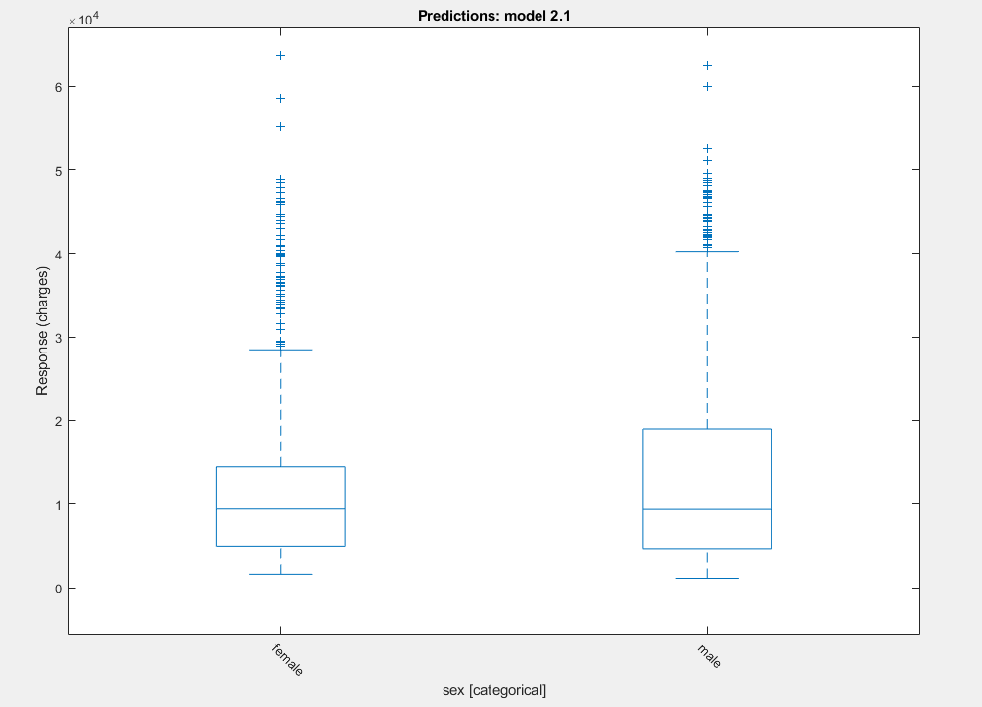
The data are very balanced between gender and region. [12]
Table 12. Descriptive pricing by number of children
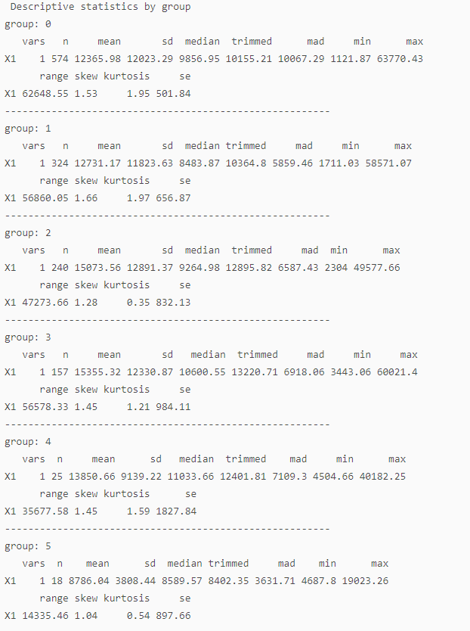

The average of 5 children and people with medical spending less than other groups, but in this case will be described in Table 19 today.

Table 13. Pricing according to the number of children boxplot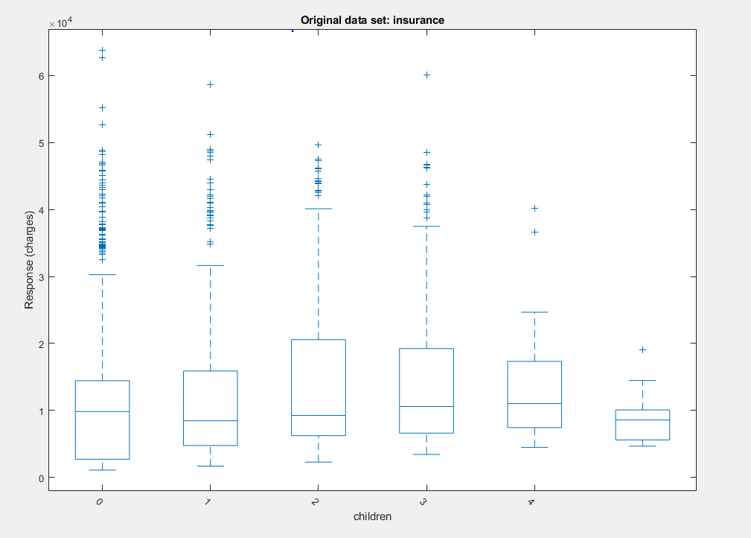
If you want to give a higher premium to obese and smokers, what kind of model do you make?
If 'bmi' exceeds 30, it is categorized as obesity. The BMI value is more than 30, yes, the non-group is collected under no group. [13]
Table 14. Descriptive pricing according to whether they are obese
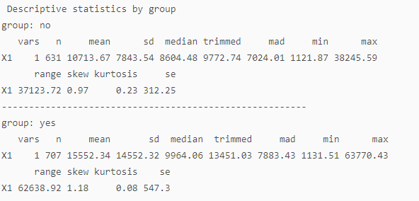

The idea behind the derivation of a new variant, obese, is that it is a bmi threshold for obesity, and we all know that obesity plays a very important role in the health of a person. As you can see, obese and non-obese people have the same median health spending, but their average spending is almost $ 5000.[15]
According to other features;
The following is the relation of the medical costs to other numerical variables.

Table 15. Other variables and values of charges subplots graph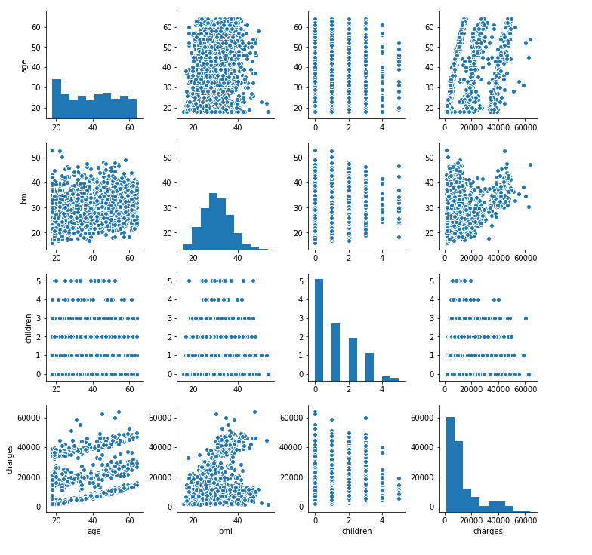

Focus on the following associations (top three charts on the bottom line):
The older the older the more money was taken.
More than 30 in BMI are considered obese. The chart also shows that individuals with Bmi> 30 will be charged higher.
Those with more children tend to earn lower wages than those who do not. [16]
On the chart, we noticed that there is a big difference between smokers and non-smokers. Let's look more at this relationship, which is complemented by other numerical variables. [17]

Table 16. Subplots graph for smoking rates among non-smokers and non-smokers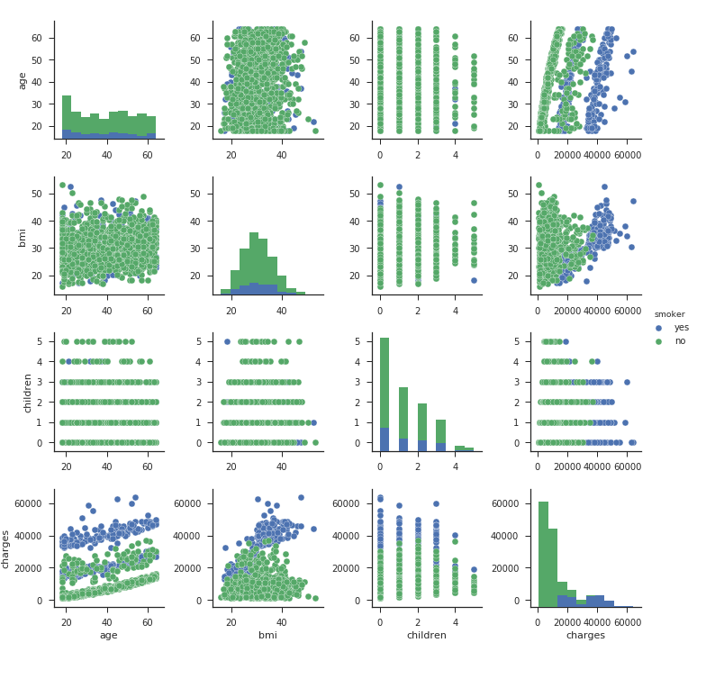

By re-focusing on the first 3 charts on the bottom, we can say that the higher amount of premiums are determined by the blue dots represented by smokers.
We can see that age has the highest correlation among numerical variables. Another observation we can make from this drawing is that none of our numerical values are highly correlated with each other, so multi-linearity will not be a problem. Another thing that should not be forgotten is that the relationship between age and wage can never be linear. [18]
We are now investigating the relationship between the features and insurance costs.

Table 17. Inter-class predictors graph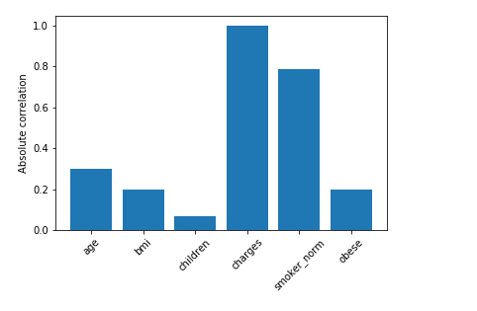
Apparently, smoking, age and obesity are the most contributing factors in the calculation of insurance costs. We will use these features only for our estimates.

Table 18. Correlation values between classes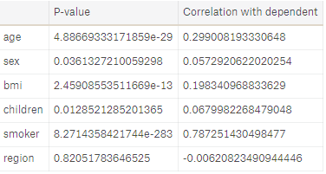
Based on the correlation analysis, we could identify the variables that affect the wage most. In particular, it is observed that most of the variables, especially smoking and age, have positive correlation with dependent variable loads and negative correlation with the region. [5]
If the sorting is done according to their size as seen;
smoker(0.7872) > age(0.299) >bmi(0.1983)
Determining the effect of the features on the medical fees;
We have already visualized the variables and the values of the charges. We are now investigating further by looking at associations using multiple linear regression. Remember that the purpose of this section is to measure the relationship and not to create a predictive model. First, let's test the dataset to create an education and continue. Based on visualization, we can make several hypotheses about the relationship. [15]
There is no real difference in charges between genders or territories.
The fee for smokers is much higher than for non-smokers.
The wage increases as the individual gets older.
The fee increases when the individual goes above 30BMI.
Finally, the fee is higher for those with fewer children.
Table 19. Table of P values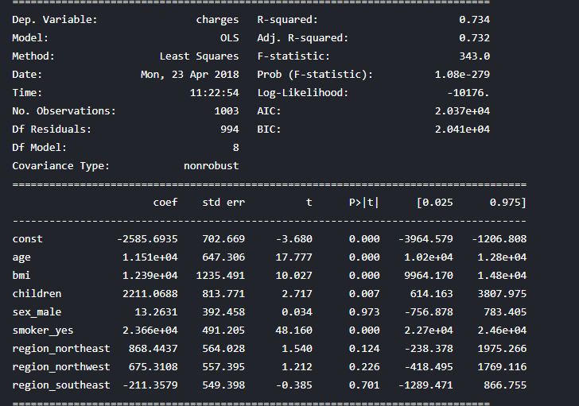
That's why we created a linear model. We see how our first hypothesis has been achieved with real results.
There is no real difference that affects wages between the sexes or regions. Conclusion: P value is 0,973 indicating no statistical difference between sex or region group.
The fee for smokers is much higher than for non-smokers. Result: P value is 0.000 indicating a difference between the groups.
The wage increases as the individual gets older. Conclusion: P value is 0.000 which indicates that the burden is higher as the person ages.
The higher the BMI, the higher the load. Conclusion: P values are 0.000 indicating that the burden is higher as the BMI increases.
Finally, there is a significant reduction in accusations as the number of children increases. Result: p value is 0.007. Interestingly, the coefficient is 2,211, which means that the wage increases because the individual has more children. The first hypothesis is wrong. This is mainly the fact that we can not rely solely on visualization to get results.
IV. LİNEAR REGRESSİON ANALİZİNİ KULLANARAK SİGORTA PRİM TAHMİNİ
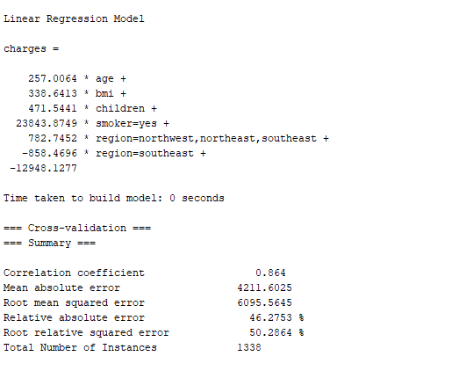
We have stated that a function is created according to the operational logic of the Linear Regression analysis and that for each value there is a predictor value for that function. Generated function;
Charges= 257.00*age + 338.64 * bmi + 471.54 * children + 23843.87 * (smoker=yes) + 782.74 * (region=northwest,northeast,southeast) - 858.46 * (region=southeast) - 12948.12 ’dir.
If we wanted to define a function without using Weka;
We will use our Linear Regression method to model our relationship between the three variables and insurance costs by fitting a linear equation to the observed data. We will apply penalties to the variables we set out above by the insurance company.
N = 3 observed multi-linear regression model:
y = ax1 + bx2 + c * x3 + i
y= health insurance
a= premium for age
b= premium for obesity, x2 will accept 1 for obese individuals and 0 for non-obese individuals.
c= premium for smokers, x3 will be the value 1 (the non-smokers will get 0, but if we ask why we need x3 in the equation, then root mean, relative absulate, root relative s-quared, mean absulate)
i = the intersection point of the equation.
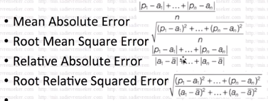
Each estimate value (p) and the real value (a) are subtracted from each other and divided into the class value. Absolute value or square taking operations do not result in negative results, so the values do not intersect. The value plotted in Root Relative Squared Error is the average of the actual value.[9]
We will make estimates using K-fold cross-validation.
In K-fold cross-validation, we divide the data into sub-clusters of equal size to form test and training clusters. Subsequently, a single sub-sample and the remaining data are treated as a test set. [10] Then, we run and test the models in all k data sets and center the estimates. Try it 10 times and using Linear Regression:
Once we have obtained the Linear Regression coefficients, we have defined a function that automatically predicts the value of an insurance cost given the age, obesity and smoking parameters.
Smokers increase health care costs (fees) by $ 23,843 a year.
As the number of children increases, health care costs (fees) can be increased by $ 471.
Prediction: An increase in dependencies can increase the cost of care such as hospital care, vaccination, and physical examination each year.)
The higher the age, the higher the medical costs.

Table 20. Obesity, smoking and coexistence of both components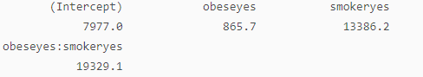
To upgrade premiums;
Obesity increases health expenditure by $ 865 and smoking increases health expenditure by $ 13,386.
However, both components are applied (if smoking and obesity coexist). Medical expenses can be expected to increase by up to $ 19,329.
For example, a 34-year-old obese and a smoker will have to pay $ 32873.87 if we use the function we set up for the insurer.

V. DISCUSSIONS
Data mining software calculates the probability of each insurance cost. In the work done, we give the 7 class data of the person as input values to the system. With these values given, insurance premiums of the person were estimated according to certain parameters. Regression and 10k-fold cross-validation were used and predicted values were obtained. Modeling with linear regression was applied to 1338 data sets. In addition to linear regression analysis, Ridge, LASSO, and ElasticNet are proposed. When the RMSE values are analyzed according to the system analyzes, 5668.84 in the linear regression analysis, 5669.24 in the LASSO analysis, 5677.40 in the ridge analysis and 5677.43 in the ElasticNet analysis were obtained. An analysis method with at least RMSE value was chosen as the result of 4 analyzes. In our study, linear regression analysis was applied to the data set consisting of 1338 data and 7 classes. The system is modeled according to the case of adding the charges values of the class. In order to increase the success rate in the algorithm during the application, the data set was tested by Linear Regression analysis with 10k cross-validation. Estimated value was calculated with a difference of 19% from the implementation of this system in which each data was converted into test data.
VI. CONCLUSIONS
By using linear regression methods, it is possible to apply different insurance premiums depending on the wages by foreseeing health expenditures. Data mining methods such as prediction, clustering, and classification can successfully detect predicted values in the light of information in large data sets. Prediction of insurance premiums can be very useful for the insurance industry. An insurance specialist needs to be consulted for the analysis of the premium values that can be changed under the influence of various factors.

Table 21. Table of facts and forecast values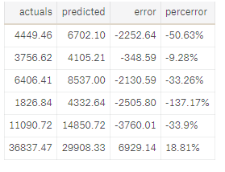
Our model was able to estimate the insurance premium with a difference of 18.81% -> 19% on average.
As expected, smokers are highly associated with the premium - that is, a smoker is likely to have a higher prime. The statistical relationship between the number of children and their salaries is surprisingly different from our visualization. Estimation values given according to the classes are given under the classification.

Table 22. The classification value table with the estimated value of Weka output
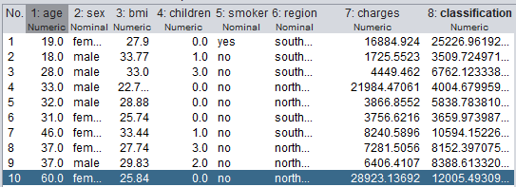

REFERENCES

1991 Economic Report of the President,p. 142 [1]
Systematic Review: Impact of Health Information Technology on Quality, Efficiency, and Costs of Medical Care [2]
Occupational status and all-cause mortality, A study with health insurance data from Nordrhein-Westfalen, Germany [3]
Bilimsel Arastırmalarda Bilgisayarlarla istatistik Uygulamaları, SPSS for Windows, Prof.Dr.Mustafa ERGÜN [4]
Uygulamalı Regresyon Ve Korelasyon Analizi, Doç.Dr.Neyran ORHUN BİLGE, İşletme Fakültesi [5]
Regression Analizi, Hacattepe Üniversitesi, Yaşar Tonya [6]
Generalized linear models for insurance data,Piet De Jong (Department of Actuarial Studies, Macquarie University, Sydney), Gillisn Z. Heller (Department of Statistics, Macquarie University, Sydney) [7]
Sağlık Ekonomisi ve Türkiye’de Sağlık Hizmetlerinin Yeniden Yapılandırılması, Dokuz Eylül Üniversitesi Sosyal Bilimler Enstitüsü Maliye Anabilim Dalı Doktora Tezi, Hilmi Çoban [8]
Medical Care, Joseph P. Newhouse, Journal of Economic Perspectives, Volume 6, Number 3 Summer 1992 [9]
Akerlof, George, "The Market fr 'Lemons': Quality Uncertainty and the Market Mechanism," Quarterly Journal of Economics, August 1970 [10]
Parkin, David, Alistair McGuire, and Brian Yule, "Aggregate Health Care Expenditures and National Income: Is Health Care a Luxury Good?," Journal of Health Economics, June 1987 [11]
Pauly, Mark V., "Taxation, Health Insurance, and Market Failure in the Medical Economy," Journal of Economic Literature, June1986 [12]
Randall P. Ellis,, Thomas G. McGuire. 1993. Supply-Side and Demand-Side Cost Sharing in Health Care. Journal of Economic Perspectives [13]
Jeffrey Clemens, Joshua D. Gottlieb. 2014. Do Physicians' Financial Incentives Affect Medical Treatment and Patient Health?. American Economic Review [14]
Scitovsky, Anne A.,"Changes in the Costs of Treatment of Selected Illnesses 1951–1965," American Economic Review, December 1967 [15]
Impact of Health Information Technology on Quality, Efficiency, and Costs, Jerome Wang, Walter Mojica,Elizabeth Roth [16]
A fraud detection approach with data mining in health insurance, North-West University, Vanderbijlpark, South Africa Marmara University, Istanbul, Turkey Melih Kirlidağ, Cüneyt Asuk [17]
Occupational status and all-cause mortality, A study with health insurance data from Nordrhein-Westfalen, Germany, Siegfried Geyer, Richard Peter [18]

